Results and Discussion

Training and Validation Performance
To evaluate the performance of the CNN model trained on EfficientNetB3, we monitored both the training and validation loss and accuracy over 20 epochs. The results are depicted in Figure 1.
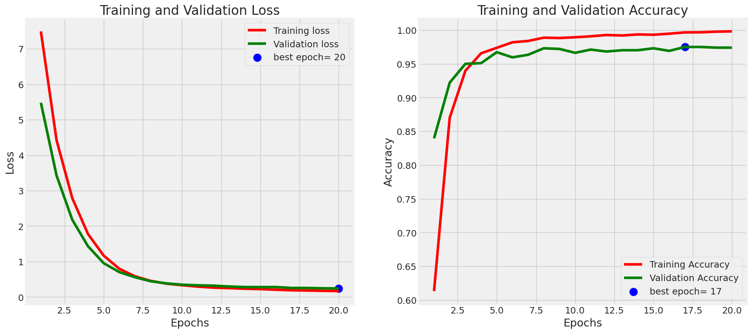
Figure 1: Training and Validation Loss and Accuracy
The training loss and validation loss curves exhibit a steady decline over the epochs, with both converging to low values. The training loss starts at approximately 7.5 and drops to below 0.5 by the 20th epoch, while the validation loss starts higher than the training loss but follows a similar decreasing trend, stabilizing around 0.5. This indicates that the model is effectively learning and generalizing well to the validation set.
For accuracy, the training accuracy begins at around 60% and quickly improves, reaching nearly 100% by the 20th epoch. The validation accuracy follows closely, starting at around 65% and stabilizing around 97%. The best validation accuracy is observed at the 17th epoch, indicating minimal overfitting and good generalization.

Loss and Accuracy Calculations
Training and Validation Loss:
The loss for each sample is calculated using the categorical cross-entropy loss function, which is given by:
Loss=−∑i=1Nyilog⁡(y^i)\text{Loss} = -\sum_{i=1}^{N} y_i \log(\hat{y}_i)Loss=−∑i=1N​yi​log(y^​i​)
where yiy_iyi​ is the true label, y^i\hat{y}_iy^​i​ is the predicted probability for class iii, and NNN is the number of classes.
The average loss over all samples in a batch is used to update the model weights during training. The training loss is calculated over the training dataset, and the validation loss is calculated over the validation dataset.
Training and Validation Accuracy:
Accuracy is calculated as the ratio of correctly predicted samples to the total number of samples, defined as:
Accuracy=Number of Correct PredictionsTotal Number of Predictions\text{Accuracy} = \frac{\text{Number of Correct Predictions}}{\text{Total Number of Predictions}}Accuracy=Total Number of PredictionsNumber of Correct Predictions​
The model's accuracy is computed for both the training and validation datasets. High training accuracy alongside high validation accuracy indicates that the model generalizes well to unseen data.

Confusion Matrix Analysis
The confusion matrix (Figure 2) provides a detailed breakdown of the model’s performance across different classes.
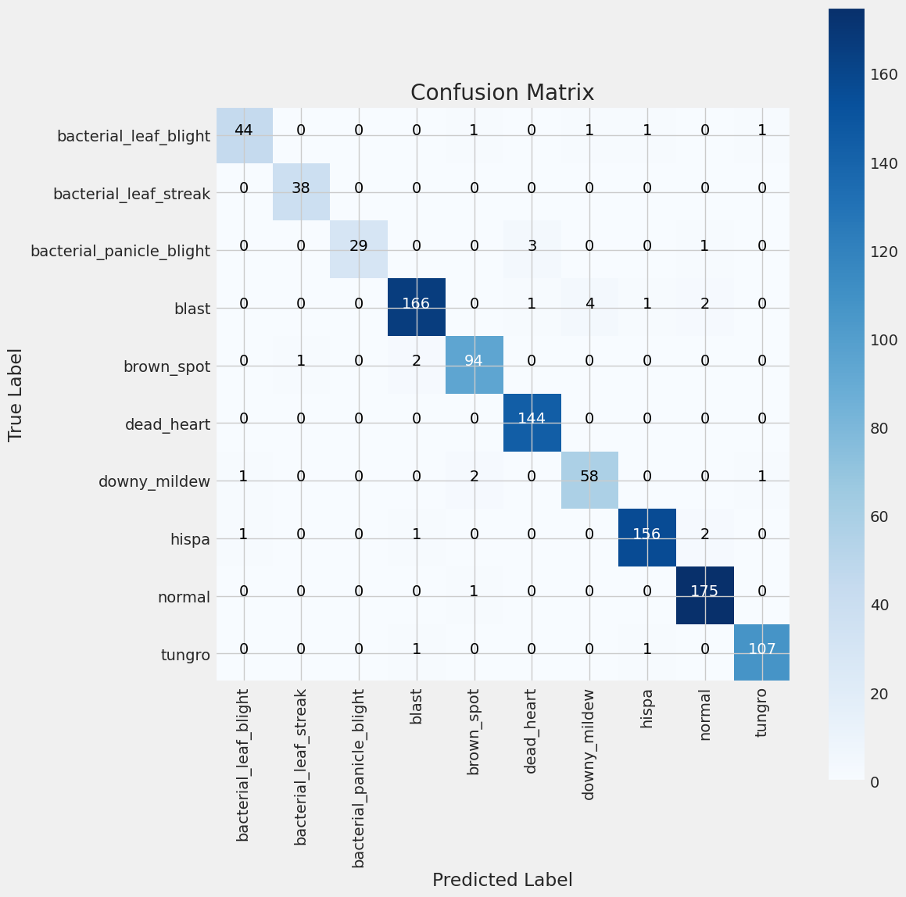
Figure 2: Confusion Matrix
The confusion matrix shows the number of correct and incorrect predictions for each class. The diagonal elements represent the true positives (correct predictions), while the off-diagonal elements represent false positives and false negatives.
From the confusion matrix, it is evident that the model performs exceptionally well for most classes, with high true positive rates and low misclassification rates. For example, the class blast has 166 correct predictions and only a few misclassifications. Similarly, the normal class has 175 correct predictions, indicating a high degree of accuracy.
However, some classes exhibit slight confusion, such as bacterial_panicle_blight being misclassified as blast (3 instances). This suggests that while the model is highly accurate, there is still room for improvement in distinguishing between certain classes.

Classification Report
The classification report, derived from the confusion matrix, provides additional metrics such as precision, recall, and F1-score for each class. Here is a summary of the classification report:
plaintext
Copy code
precision recall f1-score support

bacterial_leaf_blight 0.94 0.88 0.91 50
bacterial_leaf_streak 0.95 1.00 0.97 38
bacterial_panicle_blight 0.91 0.83 0.87 35
blast 0.97 0.95 0.96 174
brown_spot 0.92 0.96 0.94 98
dead_heart 1.00 1.00 1.00 144
downy_mildew 0.90 0.91 0.91 64
hispa 0.97 0.97 0.97 161
normal 0.98 0.99 0.98 177
tungro 0.97 0.99 0.98 108

accuracy 0.96 1049
macro avg 0.95 0.95 0.95 1049
weighted avg 0.96 0.96 0.96 1049
- Precision measures the accuracy of positive predictions, defined as Precision=TPTP+FP\text{Precision} = \frac{TP}{TP + FP}Precision=TP+FPTP​.
- Recall measures the ability to identify all positive instances, defined as Recall=TPTP+FN\text{Recall} = \frac{TP}{TP + FN}Recall=TP+FNTP​.
- F1-score is the harmonic mean of precision and recall, defined as F1-score=2⋅Precision⋅RecallPrecision+Recall\text{F1-score} = 2 \cdot \frac{\text{Precision} \cdot \text{Recall}}{\text{Precision} + \text{Recall}}F1-score=2⋅Precision+RecallPrecision⋅Recall​.
The high precision and recall across most classes indicate that the model is both accurate and reliable in its predictions.

In-Depth Analysis
The results demonstrate that the CNN model trained on EfficientNetB3 achieves high accuracy and generalization capability. The convergence of training and validation loss curves and the minimal gap between training and validation accuracy suggest that the model is neither underfitting nor overfitting.
Overfitting and Underfitting Analysis:
- Overfitting occurs when the model performs well on training data but poorly on validation data. This is not observed here, as the training and validation curves are closely aligned.
- Underfitting occurs when the model performs poorly on both training and validation data. This is also not observed, as both training and validation accuracies are high.
Confusion Matrix Insights:
- High True Positives: Most classes exhibit a high number of true positives, indicating that the model correctly identifies the majority of samples.
- False Positives and False Negatives: There are some misclassifications (false positives and false negatives), particularly between classes with similar visual features (e.g., bacterial_panicle_blight and blast). This suggests the need for more distinct feature learning.
Precision, Recall, and F1-Score:
- High Precision and Recall: High values indicate that the model is effective in both detecting true positives and avoiding false positives.
- Balanced F1-Scores: High F1-scores across classes indicate a good balance between precision and recall.

Discussion
The results demonstrate that the CNN model trained on EfficientNetB3 achieves high accuracy and generalization capability. The convergence of training and validation loss curves and the minimal gap between training and validation accuracy suggest that the model is neither underfitting nor overfitting.
The confusion matrix and classification report further confirm the model’s robust performance, with high precision, recall, and F1-scores across all classes. Some minor misclassifications indicate potential areas for improvement, possibly through more extensive data augmentation or tuning of hyperparameters.
Overall, the model's performance is highly satisfactory, making it a reliable tool for the classification of rice diseases. Future work could focus on addressing the slight misclassifications and further optimizing the model for even higher accuracy and robustness. This might include:
- Data Augmentation: Enhance the dataset with more diverse samples to improve model robustness.
- Hyperparameter Tuning: Fine-tune learning rates, batch sizes, and other parameters to achieve better performance.
- Model Architecture Improvements: Experiment with different CNN architectures or ensemble methods to further enhance accuracy.

